Module 4: Continuous Integration
- Jenkins Introduction and Steps of Jenkins Installation.
  - Jenkins Introduction:
    - Jenkins is an open-source automation server used for Continuous Integration (CI) and Continuous Delivery (CD) in software development. It helps developers automate the process of building, testing, and deploying applications.
    - Key Features of Jenkins:
- Automation: Automates repetitive tasks like code compilation, testing, and deployment.
- CI/CD Pipeline: Supports building and integrating code frequently to detect issues early.
- Plugins Support: Over 1,800 plugins for integrating with various tools like Git, Docker, Kubernetes, Maven, etc.
- Distributed Builds: Can run builds on multiple machines to speed up execution.

  - Steps of Jenkins Installation

Step 1: Go to http://www.jenkins.io/download/ and select the platform (Windows).
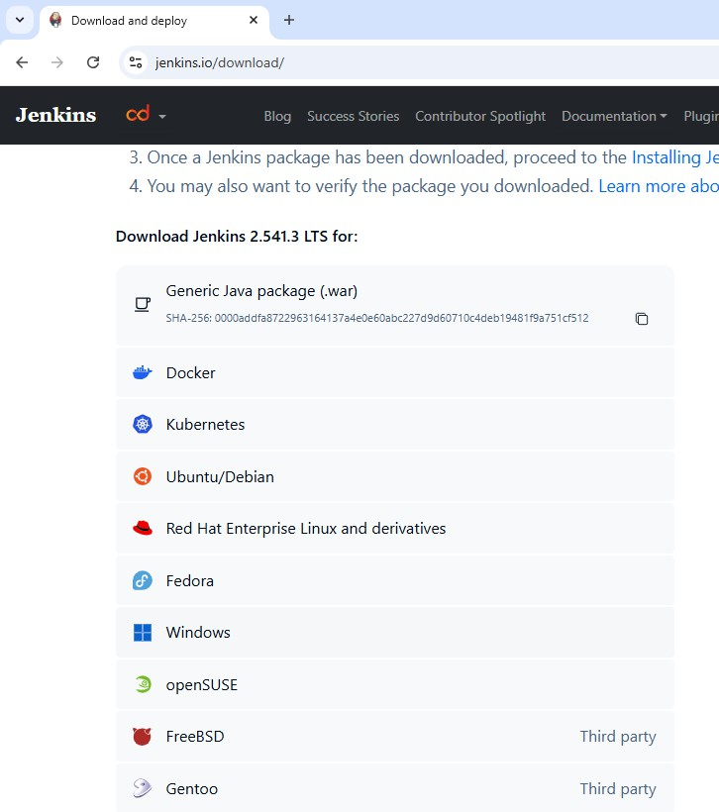

Step 2: Go to download location from local computer and unzip the downloaded package. Double-click on unzipped jenkins.msi. You can also Jenkin using a WAR (Web application Archive) but that is not recommended.
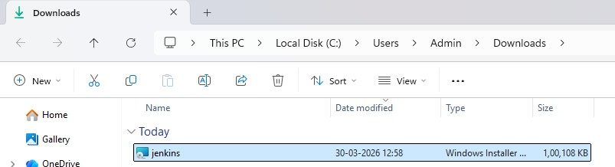

Step 3: In the Jenkin setup screen, Choose the location where you want to have the Jenkins installed and then click next.
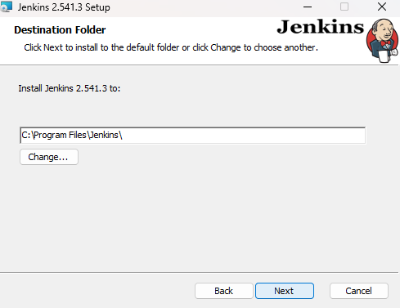

Step 4: Select run server as LocalSystem -> Click Next -> Click on Test the port (8080) -> Click next
-> Check with the jdk version which works for your case and select it and click on next
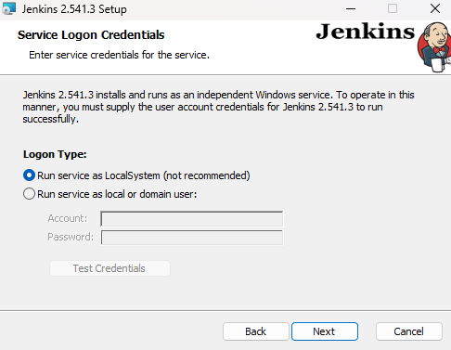
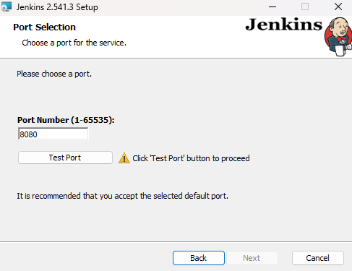

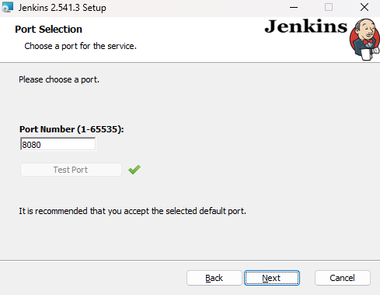
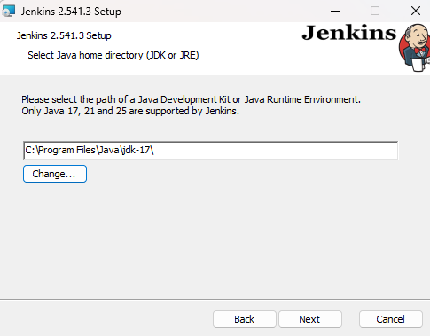

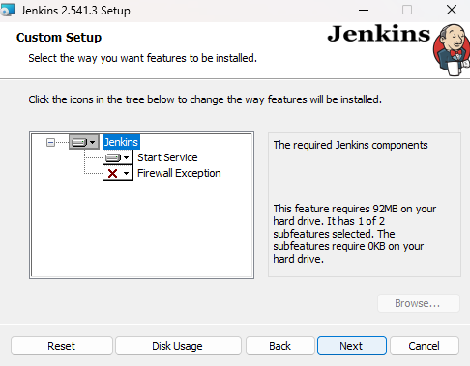

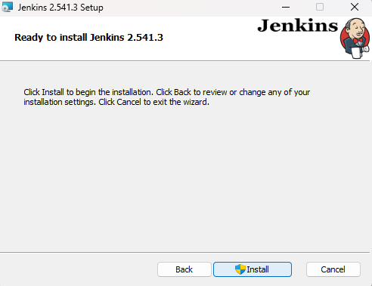
Step 5: Click on install button.

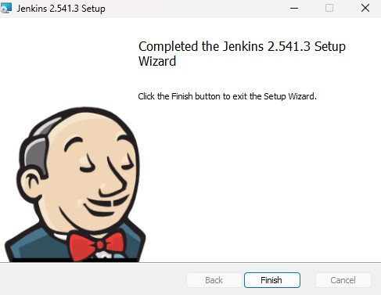
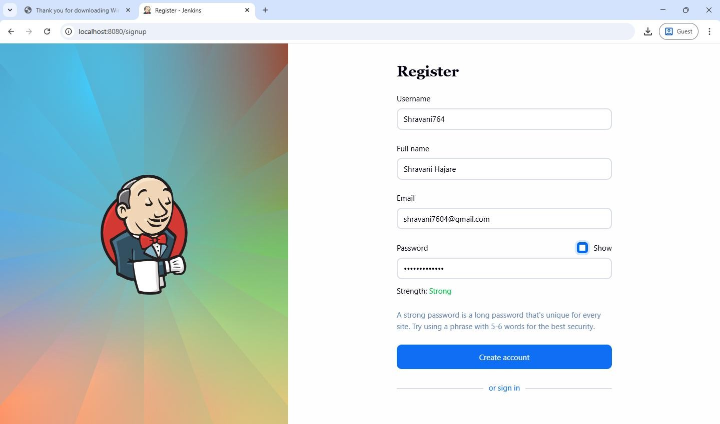
Step 6:Once Install is complete, click Finish.

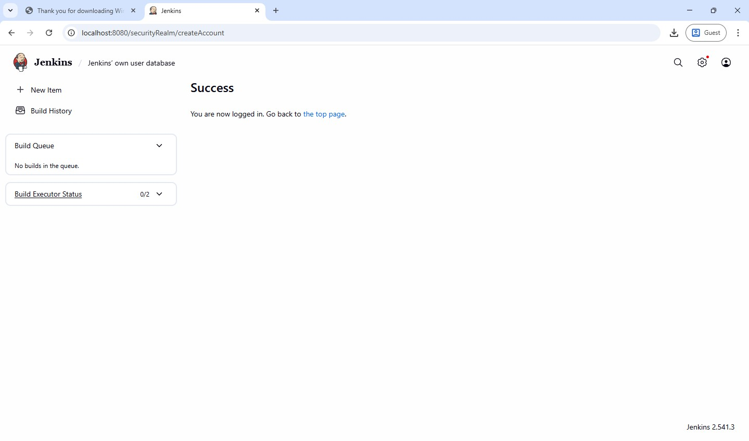

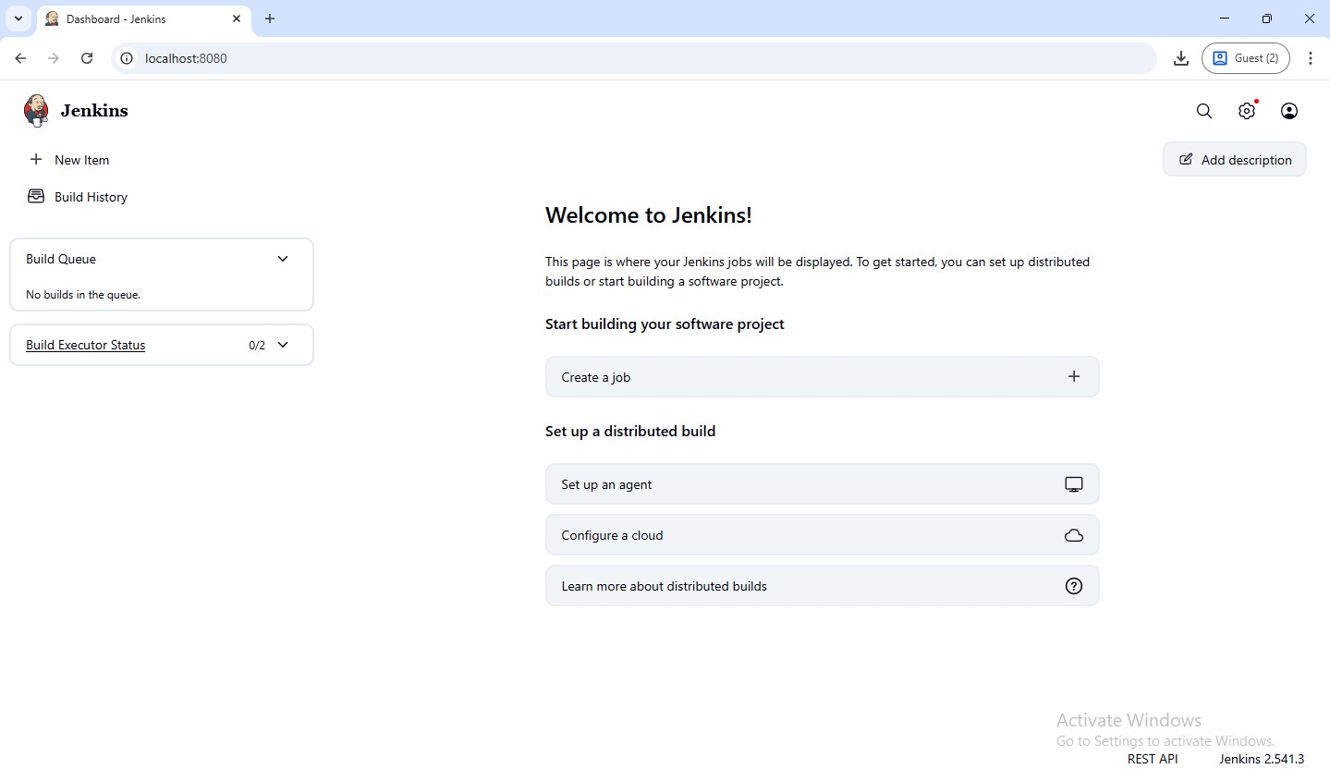

- Jenkins – Build and deploy a web application to a local HTTP Server. Step 1: Launch Jenkins -> open browser and go to http://localhost:8080
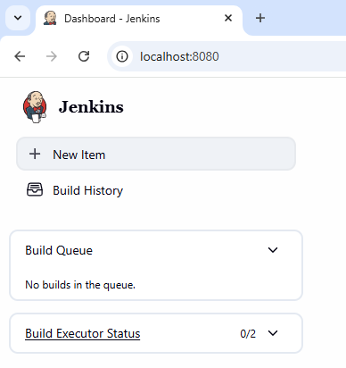
Step 2: Create a new pipeline project -> click new item -> enter project name and select pipeline and click ok
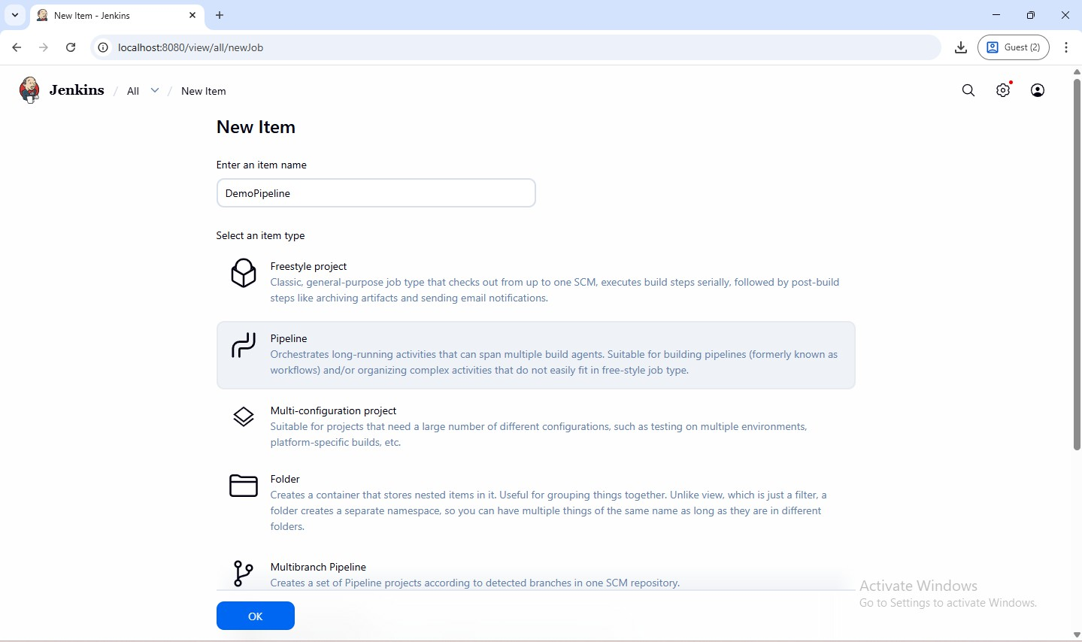

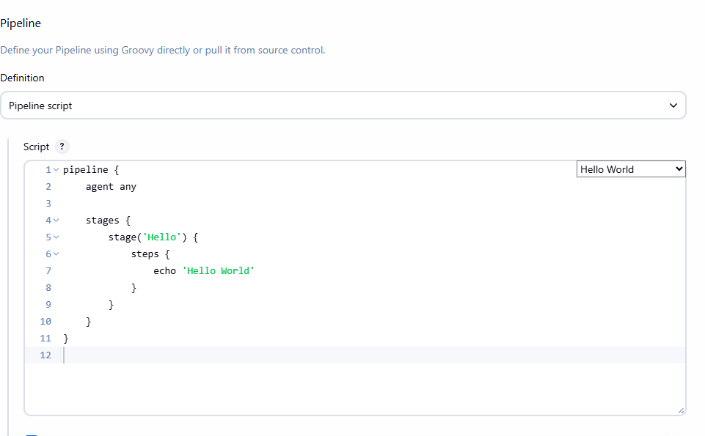
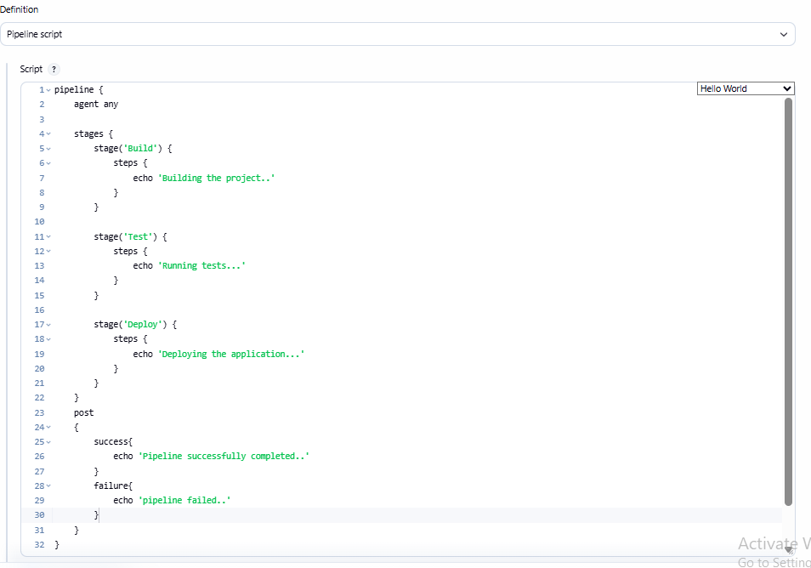
Step 3: Configure Pipeline Script -> Scroll to pipeline section and add the following and click save.

Step 4: Build Stage -> This stage simulates compiling/ building the web application.
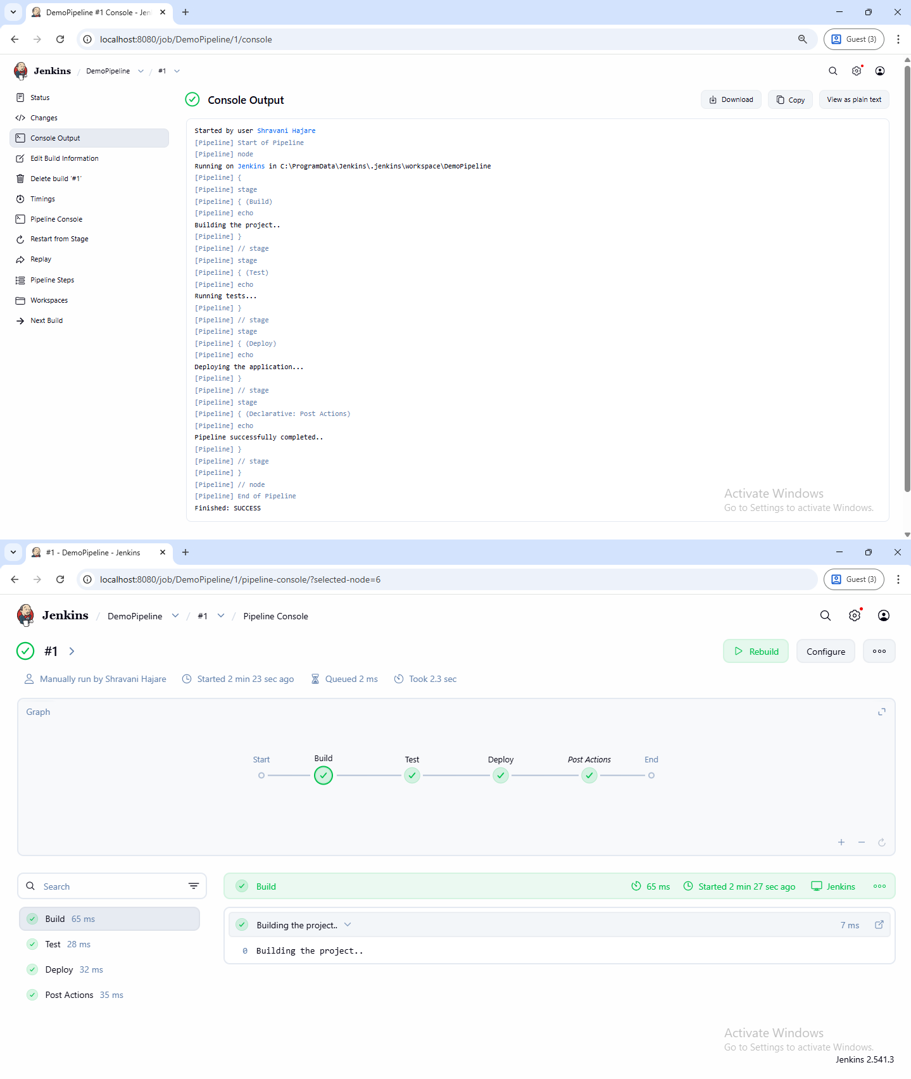

Step 5: Test Stage -> executes test cases for application
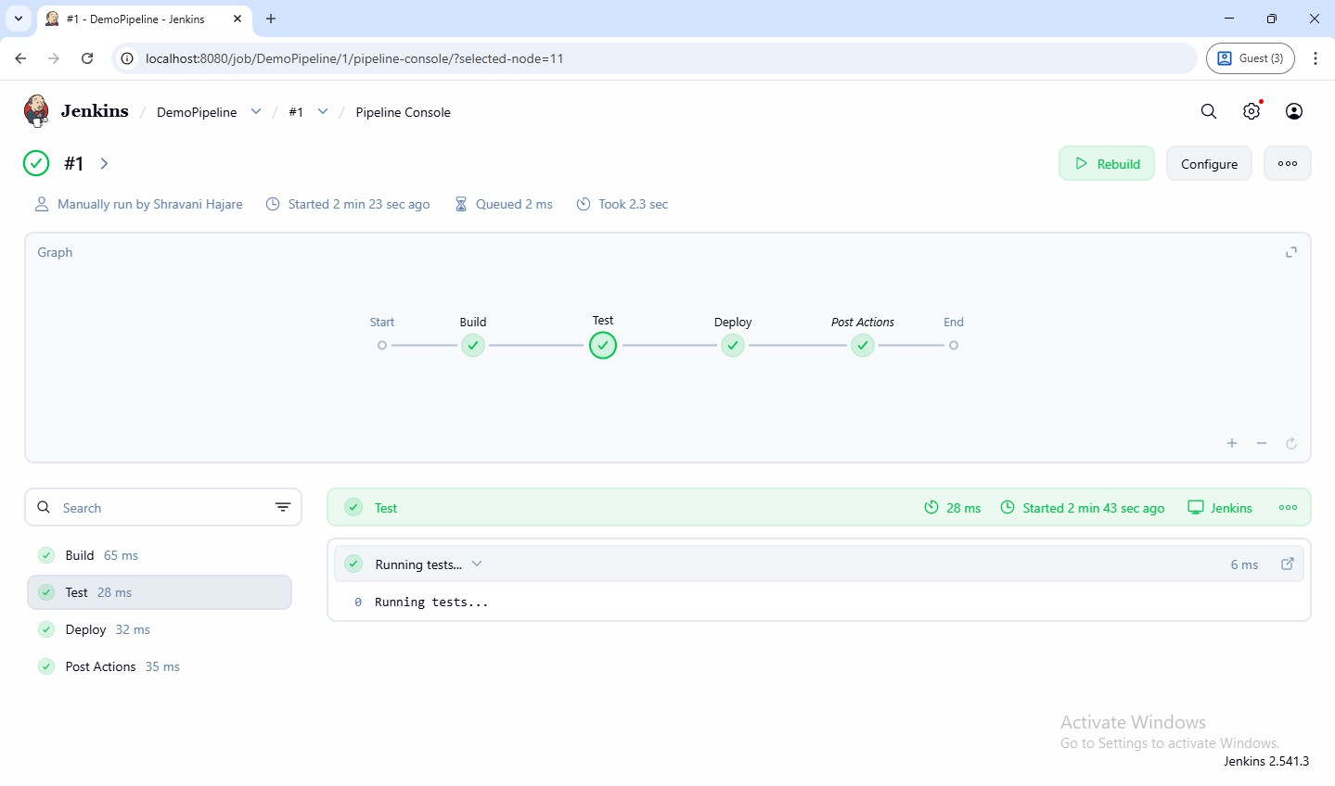
Step 6: Deploy Stage -> deploys the application to local HTTP server
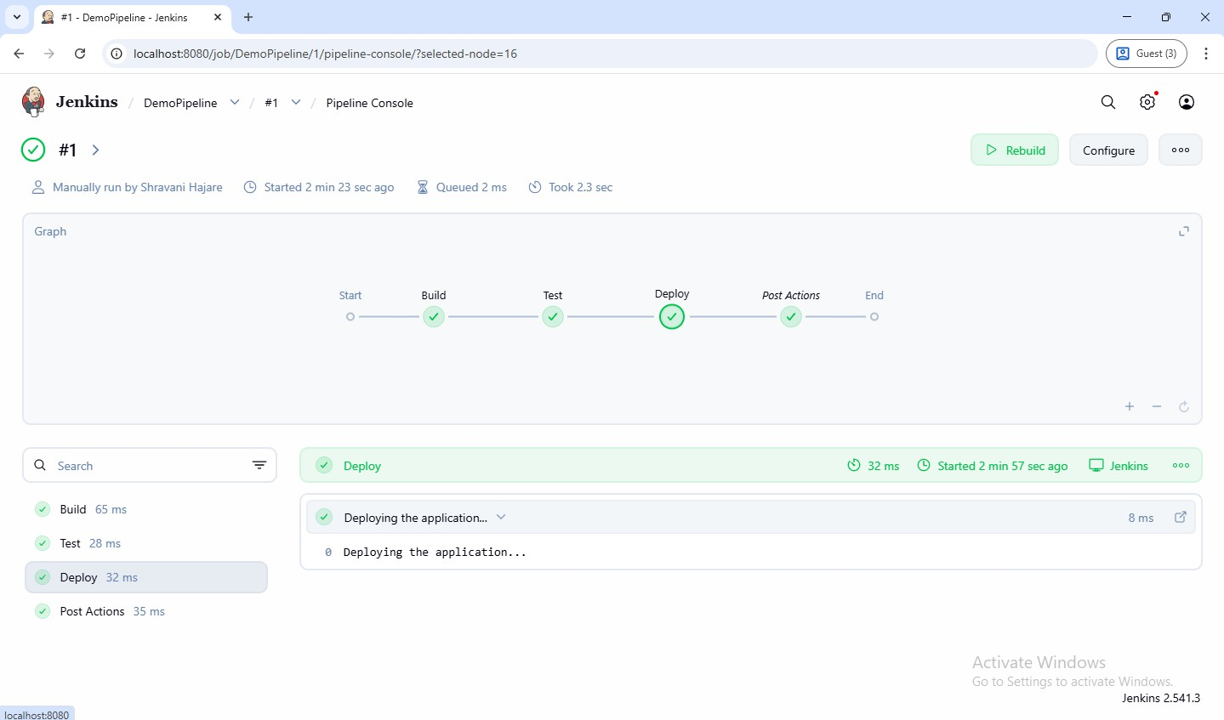

After successfully completing the deployment
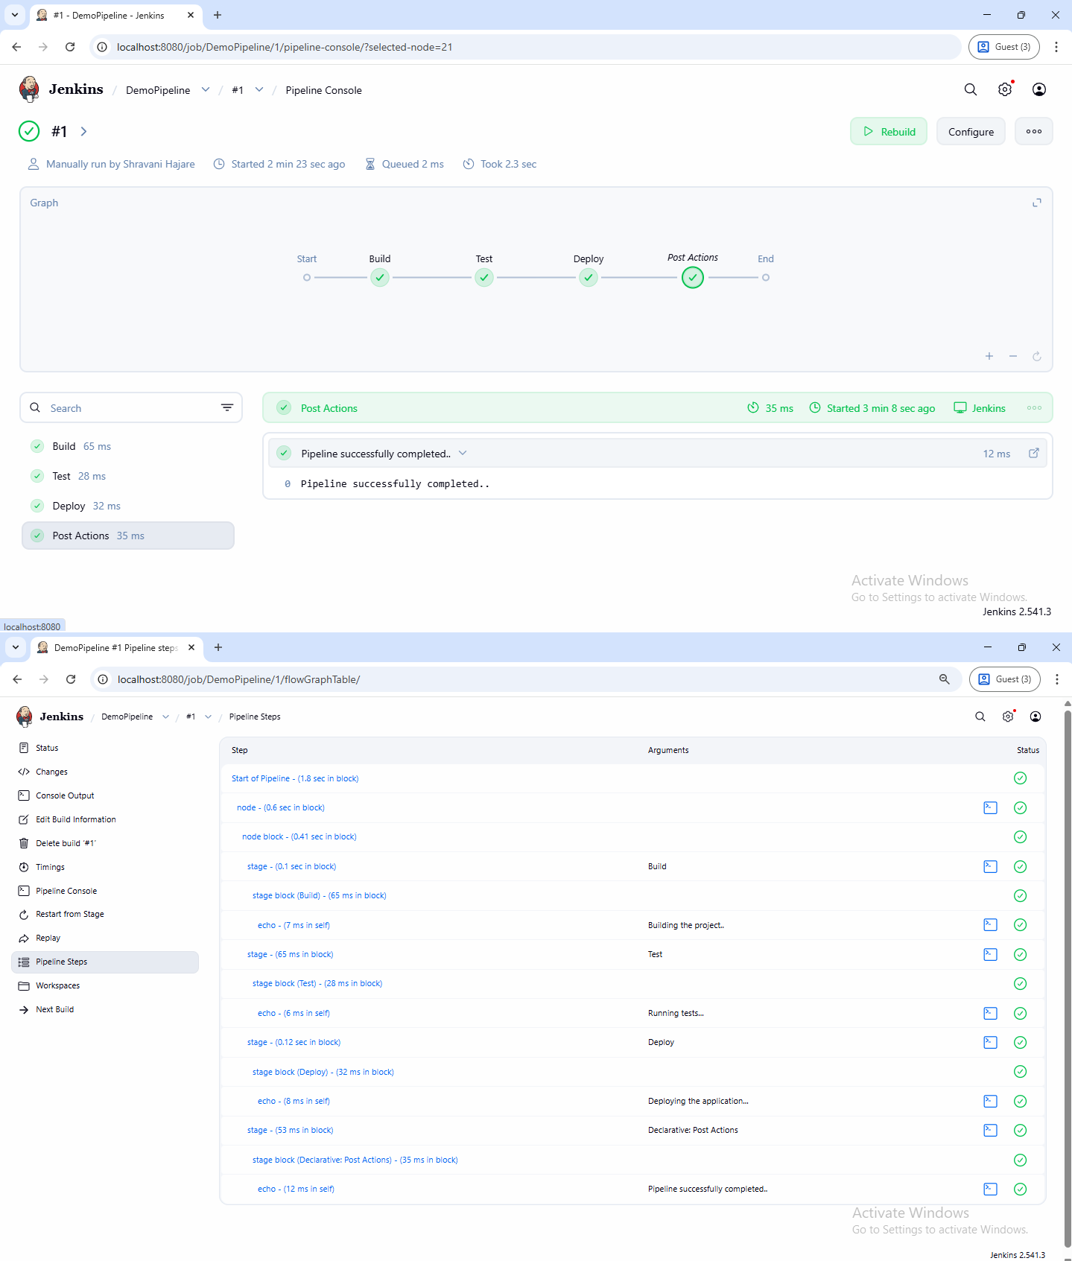

- Jenkins – Integrating Jenkins with GitHub and Demonstrate Continuous Integration and Development using Jenkins(Login Page Html).
Step 1:Create the HTML login Page
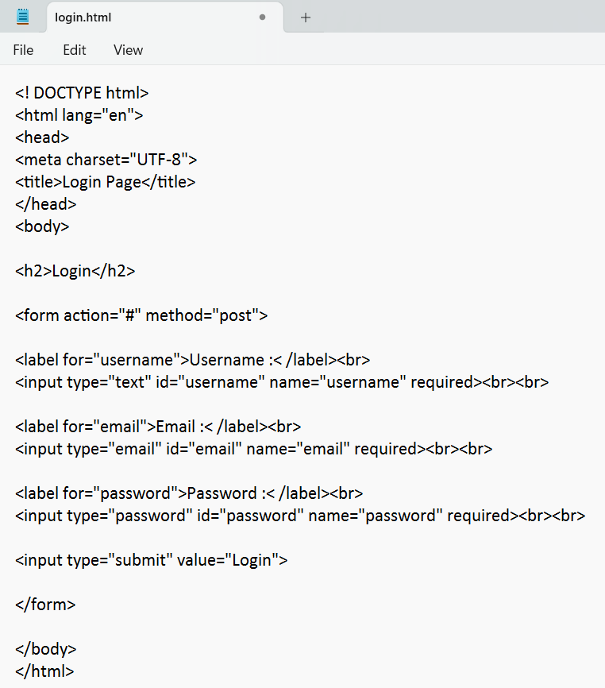

login.html
<! DOCTYPE html>
<html lang="en">
<head>
<meta charset="UTF-8">
<title>Login Page</title>
</head>
<body>
<h2>Login</h2>
<form action="#" method="post">
<label for="username">Username :< /label><br>
<input type="text" id="username" name="username" required><br><br>
<label for="email">Email :< /label><br>
<input type="email" id="email" name="email" required><br><br>
<label for="password">Password :< /label><br>
<input type="password" id="password" name="password" required><br><br>
<input type="submit" value="Login">
</form>
</body>
</html>

Step 2: Upload the project to GitHub repository
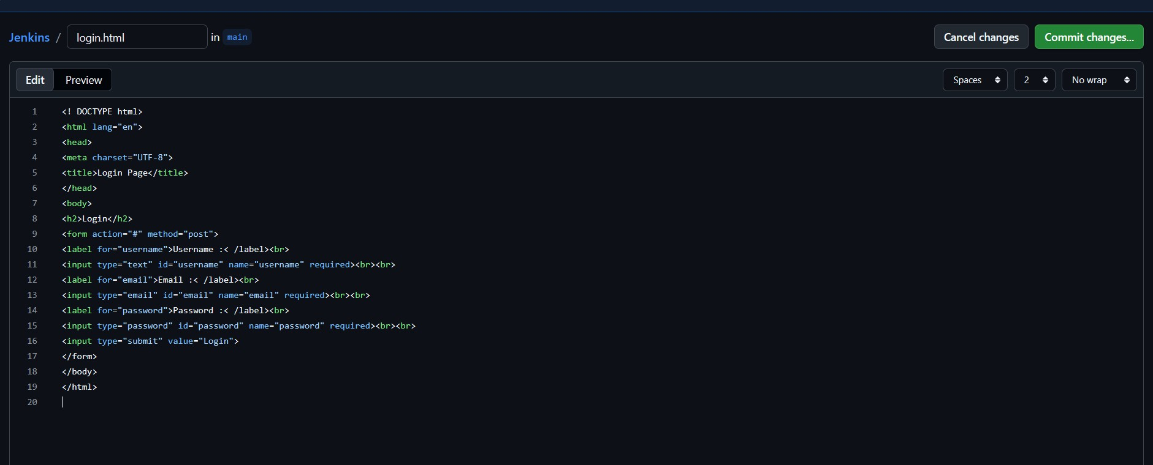
Step 3: Create a new Jenkins project
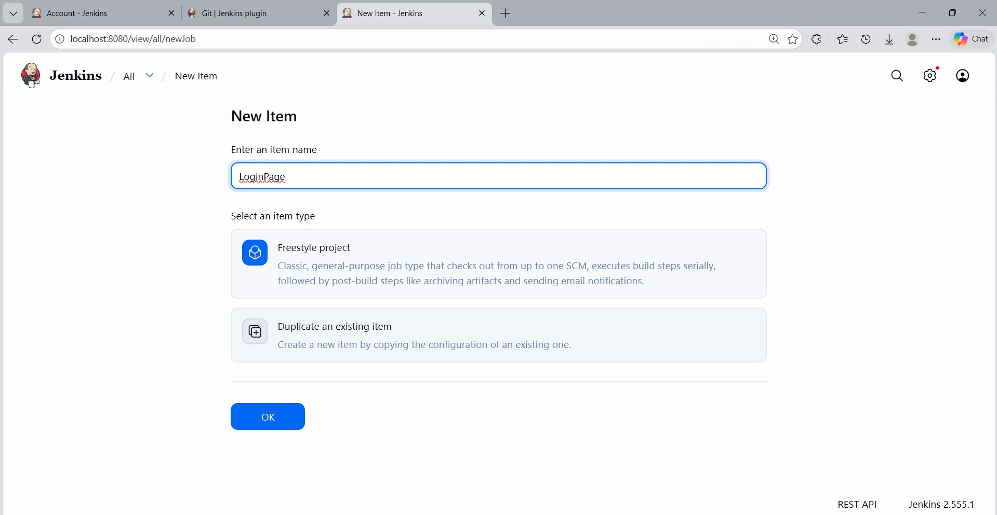

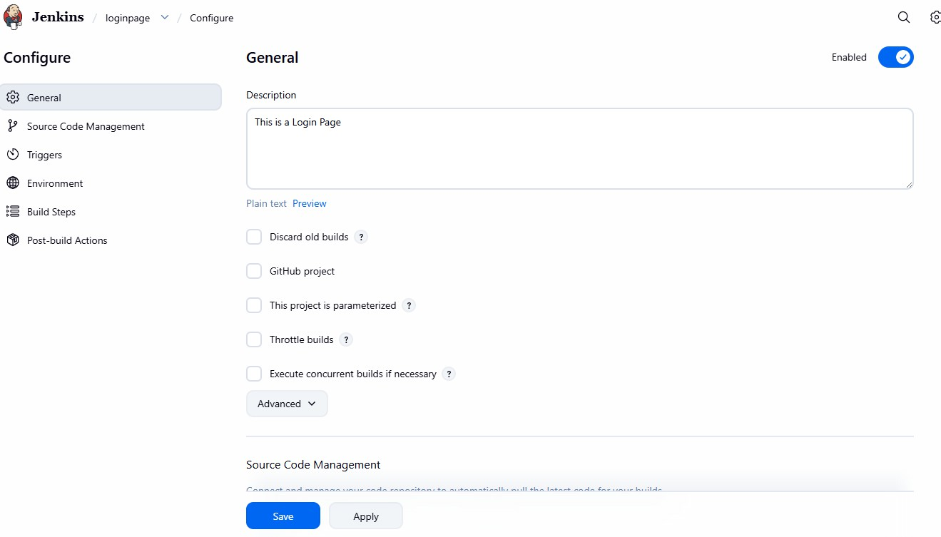
Step 4: Configure general project settings
Step 5: Configure Source Code Management -> select Git
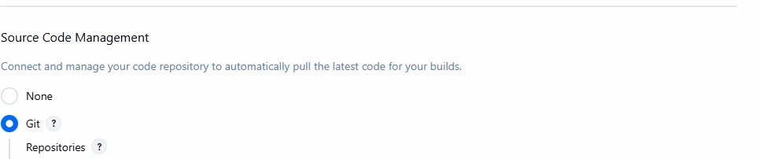

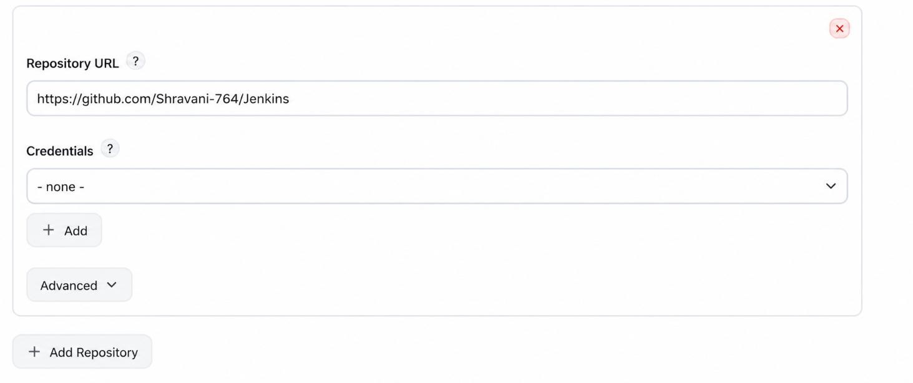

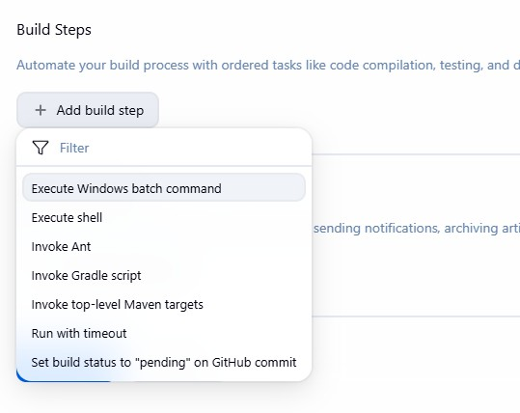
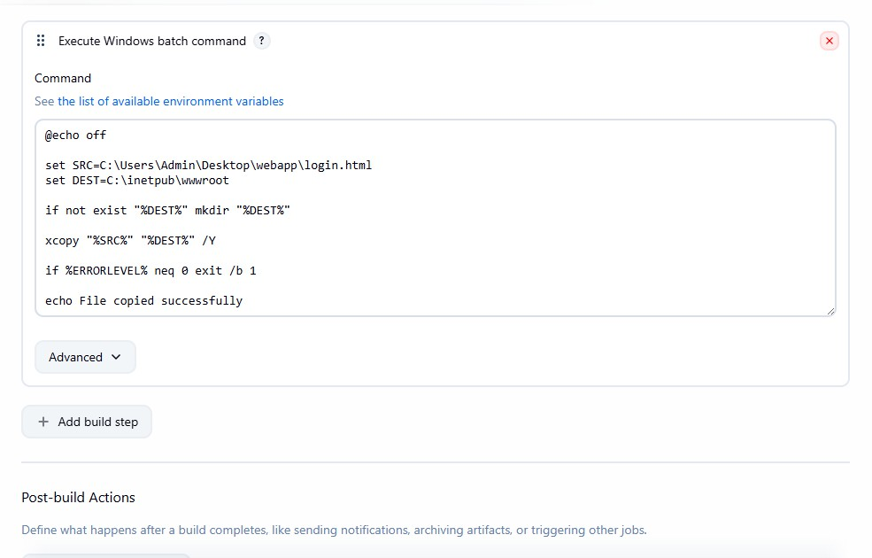
Step 7: Configure build steps
Step 8: Save the job configuration Step 9: Trigger the build

